Project Name: Snake_enhanced.html

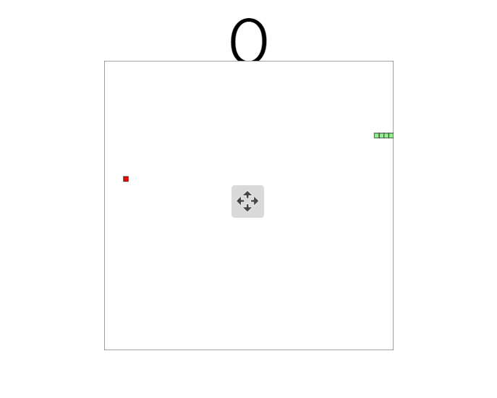

Description:

This project creates the Snake Game seen in the Worked Example using HTML5, JavaScript and CSS for design and implementation, and data representation.

Let's start by looking at the snake itself, the hero of the game. The snake has a location on the screen, and contains multiple visual elements, as it can grow, and the snake's head is connected to the rest of the snake and the snake's body follows it around the screen. If the snake "eats" food, it grows. The snake also keeps track of which way it’s going

Project Outcome:

* To create a Snake game that allows users to control the movement of a snake on a screen, to get points for eating food
* Graphical representation of a snake moves across the screen. When it encounters a piece of food, the snake grows longer and we gain 10 point.
* With one-minute time limit the game will end.

Requirements of this Program:

1. The snake must appear to move around the screen

2. The snake must turn in response to user input

3. The snake will increase in length if it eats food

4. The snake will die if it runs over itself

5The snake never stops moving

Steps for developing program

1. Draw the playing area with bounding rectangle.
2. Set the counter to zero and display it.
3. Draw the snake in a starting position.
4. Draw the food in a starting location.
5. On user input, change snake direction.
6. Move the snake one move
7. If the snake is over food, eat it, increase the score, grow, move the food,
8. The snake will die if it hits into the walls
9. Draw Canvas

<canvas id="gameCanvas" width="500" height="500"></canvas>

**// Get the canvas element**

const gameCanvas = document.getElementById("gameCanvas");

**// Return a two dimensional drawing context and get gradient**

const ctx = gameCanvas.getContext("2d");

var grd = ctx.createLinearGradient(0, 0, 300, 0);

**\* Change the background colour of the canvas to CANVAS_BACKGROUND_COLOUR and**

**draw a border around it**

function clearCanvas() {}

**Draws a part of the snake on the canvas**

function drawSnakePart(snakePart)

**Draws the snake on the canvas**

function drawSnake() {}

**Advances the snake by changing the x-coordinates of its parts**

**according to the horizontal velocity and the y-coordinates of its parts**

**according to the vertical veolocity**

function advanceSnake() {}

**Draw the food on canvas:**

function drawFood() {}

**Create Food with random function:**

function createFood() {}

**call all the functions in sequence and call itself at the end to iterate.**

main () {} : Main function of the game

called repeatedly to advance the game

**Changes the vertical and horizontal velocity of the snake according to the**

**key that was pressed.**

function changeDirection(event) {}

**Game End:**

function didGameEnd() {}

**Enhancements:**

* Add background image for page
* Add Gradient Colour for Canvas
* Increase the Size of snake and Food
* Change the Snake Head Colour
* Add Pause and Play Button
* Add Score and Timer display boards
* Accelerate and decelerate the Crawling speed of the Snake
* Snake Pass through the walls

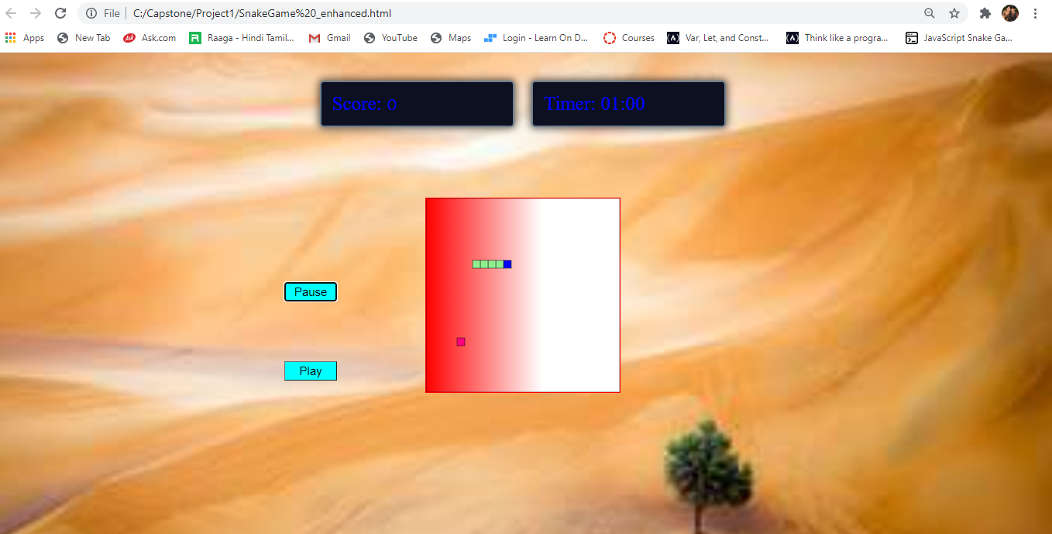

1. Add background image for page : Instead of white background placed an

Image for look and feel.

1. Add Gradient Colour for Canvas: Added red and white gradient colours to the Canvas.
2. Increase the Size of snake and Food: Increase the distance of coordinates of dx and dy for both snake and food.
3. Change the Snake Head Colour: change the snake head colour to Blue colour.
4. Add Pause and Play Button: Pause the game and Play the game without refreshing page.
5. Add Score and Timer display boards: Set the countdown timer to 1 min

When snake eats food Score box shows increased Score.

1. Accelerate and decelerate the Crawling speed of the Snake: Accelerate and

Decelerate the snake speed with Page up and Page down Keys.

1. Snake Pass through the walls: Instead of hitting wall snake pass through the walls.

**TestCases:**

|  |  |  |  |
| --- | --- | --- | --- |
| TestCase | Description | Expected Result | Actual Result |
| Increase the Size of snake and Food | Food x and y  Horizontal velocity and Vertical velocity are matching | Size of food and Snake Increases and must co-ordinate with each other | Pass |
| Accelerate and decelerate the Crawling speed of the Snake | Snake speed can control with pg up and pg dn keys | Control Snake speed without miss the food | Pass |
| Add Score and Timer display boards | Display of Scores and 1 min countdown timer | Timer should match with server timing | Fail  Not matching (2 sec difference) |
| Add Pause and Play Button | Paused the game and Play the game | Pause and play the game | Pass |

Further Enhancements:

1. Should Create Multiple types of Random foods
2. Timer Should match with server time
3. Add mouse Controllers to the game